Section A: Multiple Choice: (Nos. 1-8, 1 mark each)

Use the multiple choice answer sheet on page 4

1. What is the main criterion for designating the corresponding layers of the atmosphere?

(A) The composition of each layer
(B) The temperature in each layer
(C) The density of each layer
(D) The type of reaction occurring in each layer

2. The formation of ozone in the troposphere is due to which situation?

(A) presence of the very short UV radiation acting on an oxygen molecule
(B) presence of medium short frequency UV radiation acting on nitric oxide molecules
(C) presence of low frequency UV radiation acting on nitrogen dioxide molecules
(D) presence of medium high frequency UV acting on hydrocarbons

3. The condensed structural formula of the compound is CF₃CHClCH_{3.} What is its
systematic name?

(A) 2-chloro-1,1,1-trifluoropropane
(B) 2-chloro-3,3,3-trifluoropropane
(C) 1,1,1-trifluro-2- chloropropane
(D) 3,3,3-trifluro-2-chloropropane

4. Which chemical reaction given below supports the information given in the following diagram?
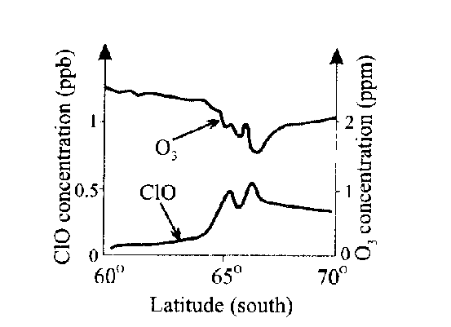

(A) 2 ClO (g) → Cl₂O₂(g)
(B) Cl₂O₂ (g) → 2 Cl (g) + O₂(g)
(C) ClO(g) + O₂(g) → Cl(g) + O₃(g)
(D) Cl(g) + O₃(g) → ClO(g) + O₂ (g)

5. Which of the following choices correctly describes the thermosphere, troposphere and stratosphere?

 | THERMOSPHERE | TROPOSPHERE | STRATOSPHERE
(A) | Ozone destroyed in this layer  due to high temperature | Lowest layer of the atmosphere | Ozone produced in this layer
(B) | Hottest layer | Layer surrounding the Earth’s surface | Layer with the most pollutants
(C) | CFCs destroyed in this layer | Ozone formed in this layer due to  high UV flux | Highest layer
(D) | Highest layer | Layer with the most pollutants | Ozone formed and destroyed  in this layer

6. Water authorities regularly test drinking water to ensure the health of the
populace. Which of the test profiles would be indicative of high quality water?

 | TDS | DO | BOD
(A) | high | high | high
(B) | high | low | high
(C) | low | high | low
(D) | low | low | low

7. The table lists ions to be identified and test solutions.

ION TO BE IDENTIFIED | TEST SOLUTION USED
1. Ba ²⁺ | 5 AgNO₃
2. Cl – | 6 BaCl₂
3 CO₃ ^{2–} | 7 HNO₃
4 SO₄ ^{2–} | 8 H₂SO₄

Which of the following sets shows the correct matching?

(A) 1 + 8; 2 + 5; 3 + 7; 4 + 6
(B) 1 + 5; 2 + 8; 3 + 6; 4 + 7
(C) 1 + 7; 2 + 6; 3 + 5; 4 + 8
(D) 1 + 6; 2 + 7; 3 + 8; 4 + 5

8. Study these Lewis electron dot structures…
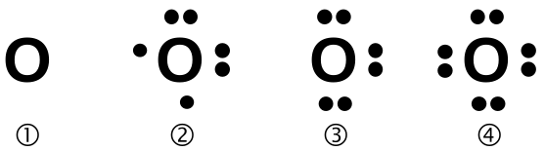


Which pair represents the correct structures of oxygen (free radical) and ozone?

(A) 1 and 6
(B) 2 and 7
(C) 3 and 8
(D) 4 and 5
Answer Booklet for Sections A and B Student No....................................

INSTRUCTIONS
Use the multiple choice answer sheet below.
Select the alternative A, B, C or D that best answers the question. Fill in the response square completely.

Sample 2+4= (A) 2 (B) 6 (C) 8 (D)9

A  B l C  D 

If you think you have made a mistake, put a cross through the incorrect answer and fill in the new answer.

A l B l C  D 

If you change your mind and have crossed out what you consider to be the correct answer, then indicate this by writing the word correct and drawing an arrow as follows:

correct

A l B l C  D 

Section A

Multiple Choice Answer Sheet

1. A  B  C  D 

2. A  B  C  D 

3. A  B  C  D 

4. A  B  C  D 

5. A  B  C  D 

6. A  B  C  D 

7. A  B  C  D 

8. A  B  C  D 

MARKS

Section B:
Short Answer Questions

Question 9 (3-marks)
Your recent labwork involved the identification of the following ions…

phosphate, sulfate, carbonate, chloride, barium, calcium, lead,
copper and iron

(a) Identify one of these ions and explain why its presence must be
monitored in substances used by society. 2

.................................................................................................................

..................................................................................................................

...................................................................................................................

(b) Describe the chemical test and a positive result for the presence of the
aqueous ion identified in (a) 1

......................................................................................................................

.....................................................................................................................

.....................................................................................................................

Question 10 (1 mark)

The following reactions can occur in the atmosphere…

• H₂O (l) 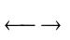 H₂O (g)
• CF₂Cl₂ 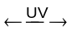 CF₂Cl + Cl
• O₂ + O 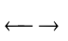 O₃
• SO₂ + H₂O 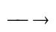 H₂SO₃

Draw the Lewis electron dot structure of a free radical species found above. 1

MARKS
Question 11 (2-marks)

Describe the conditions under which rusting of iron occurs. Use half equations
to support your answers 2

..................................................................................................................................

...................................................................................................................................

....................................................................................................................................

...................................................................................................................................

..................................................................................................................................

Question 12 (3 marks)

Describe the work of Davy and Faraday in increasing understanding of
electron transfer reactions. 2

........................................................................................................................................

.........................................................................................................................................

..................................................................................................................……...............

.................................................................................................................……..............

.................................................................................................................……..............

Question 13 (3 marks)

Identify alternative chemicals used to replace CFCs and evaluate the
effectiveness of their use as a replacement for CFCs. 3

…………………………………………………………………………………………..

…………………………………………………………………………………………..

…………………………………………………………………………………………..

…………………………………………………………………………………………..

…………………………………………………………………………………………..

MARKS

Question 14 (3 marks)

Describe the design and composition of microscopic membrane filters
and explain how they purify contaminated water. 3

…………………………………………………………………………………….

…………………………………………………………………………………….

…………………………………………………………………………………….

……………………………………………………………………………………..

……………………………………………………………………………………..

END OF PART 1 

